Exercise 9
  - Machine Learning I

9A-1.

Let $f:R^{n}→R$. Recall, that the real valued partial derivative can be defined with respect to the standard basis:

Prerequisites
$$\frac{∂f}{∂x_{i}}=\lim_{\begin{matrix}h→0 \\ h>0\end{matrix}}{\frac{f\left(x+he_{i}\right)-f\left(x\right)}{h}}$$

where $e_{i}$ denotes the $i$th (standard) basis vector. This leads to:

$$\begin{matrix}units\frac{∂f}{∂x_{i}} & =units\lim_{\begin{matrix}h→0 \\ h>0\end{matrix}}{\frac{f\left(x+he_{i}\right)-f\left(x\right)}{h}} \\ & =\frac{units f}{units h}\end{matrix}$$
As $he_{i}$ only adds to the $x_{i}$-th entry and unit vectors are generally unitless, we have
$$units h=units x_{i}$$

We are now ready to investigate the units!

Gradient descent
For $α∈R^{+}$, we have the gradient update:
$$\begin{matrix} & x^{t+1} & =x^{t}-α∇f \\ & & \\ ⇒ & x_{i}^{t+1}-x_{i}^{t} & =-α\frac{∂f}{∂x_{i}}, ∀ i:1,..,n \\ & & \end{matrix}$$
From a units perspective, this leads to:
$$\begin{matrix}units α\frac{∂f}{∂x_{i}} & =units α\frac{units f}{units x_{i}}\end{matrix}$$
Therefore $units x_{i}=units α=\frac{units x_{i}^{2}}{units f}.$ We omitted the “-“ in front of the $α$ as it does not affect the units.
In the task, $f$ is dimensionless and $units x_{1}=m,units x_{2}=kg$.
Therefore, the two update steps have for each dimension:
$$\begin{matrix}units α\frac{units f}{units x_{1}} & =\underset{units α}{\underbrace{\frac{m^{2}}{1}}}∙\frac{1}{m} \\ units α\frac{units f}{units x_{2}} & =\frac{{\left(kg\right)}^{2}}{1}∙\frac{1}{kg}\end{matrix}$$
As can be seen, $α$ must have different units for both dimensions in order to compensate for the incompatible units. As $α$ is theoretically a scalar, this would not be possible.

Momentum gradient descent
For $γ,α∈R$, we have the gradient update:
$$\begin{matrix} & x^{t+1} & =x^{t}-\underset{v_{t+1}}{\underbrace{\left[γv_{t}+α∇f\right]}} \\ & & \\ ⇒ & x_{i}^{t+1}-x_{i}^{t} & =-\left[γv_{ti}+α\frac{∂f}{∂x_{i}}\right], ∀ i:1,..,n \\ & & \end{matrix}$$
From a units perspective, this leads to:
$$\begin{matrix} & units\left[γv_{ti}+α\frac{∂f}{∂x_{i}}\right] & =units γ∙units v_{ti}+units α\frac{∂f}{∂x_{i}} \\ \left(*\right) & & =units γ∙units v_{ti}+units α\frac{units f}{units x_{i}}\end{matrix}$$
From the definition of the gradient updates, we also have:
$$units v_{ti}=units x_{i}^{t}$$
Setting this equality into $\left(*\right)$, we arrive at:
$$units γ∙units v_{ti}+units α\frac{units f}{units x_{i}}=units γ∙units x_{i}^{t}+units α\frac{units f}{units x_{i}}$$
To add the units on the right side additively, we have:
$$units γ∙units x_{i}^{t}=units α\frac{units f}{units x_{i}}$$
As this all has to be equal to $units x_{i}^{t}$, (because $v_{n+1}$ needs the same units as $x^{t}$) we arrive at:
$$units α=\frac{units x_{i}^{2}}{units f}$$
$$units γ=1$$
Therefore $γ$ is dimensionless. Again, the units are not consistent, because
$units α$ is dependent on $units x_{i}^{t}$ (Which it shouldn’t as $α$ is a scalar and could theoretically not give different units for each component of $x$).

AdaGrad
A very nice explanation about the notation and AdaGrad can be seen in the lecture PyBook or be found here:
https://medium.com/konvergen/an-introduction-to-adagrad-f130ae871827
For $α∈R^{+}$, we have the gradient update:
$$\begin{matrix} & x^{t+1} & =x^{t}-\frac{α}{\sqrt{ϵI+diag\left(G_{t}\right)}}∇f_{t} \\ & & \\ ⇒ & x_{i}^{t+1}-x_{i}^{t} & =-\frac{α}{\sqrt{ϵ+G_{t}^{\left(i,i\right)}}}\frac{∂f_{t}}{∂x_{i}}, ∀ i:1,..,n \\ & & \end{matrix}$$
From a units perspective, this leads to:
$$\begin{matrix}units\left[α{\left(ϵ+G_{t}^{\left(i,i\right)}\right)}^{-\frac{1}{2}}\frac{∂f_{t}}{∂x_{i}}\right] & =units α∙units{\left(ϵ+G_{t}^{\left(i,i\right)}\right)}^{-\frac{1}{2}}∙units\frac{∂f_{t}}{∂x_{i}} \\ & =units α∙\frac{units x_{i}}{units f}∙\frac{units f}{units x_{i}} \\ & =units α\end{matrix}$$

Therefore, $units α=units x_{i}$, which again is not consistent across all dimensions.

AdaDelta
For description see here:
http://ruder.io/optimizing-gradient-descent/index.html#adadelta
From a units perspective, AdaDelta differs from AdaGrad only by the corrective factor $RMS{\left[Δx\right]}_{t-1}$ in the nominator. This corrective factor will have $units RMS{\left[Δx\right]}_{i}=units x_{i}$, therefore AdaDelta is consistent across units. Therefore, its units will not be consistent.

RMSProp
From a units perspective, the update rule is similar to AdaGrad without the corrective factor in the nominator.
There are many more Gradient descent algorithms available. A good overview of the more common ones, can be found here:
http://ruder.io/optimizing-gradient-descent/

9A-2.

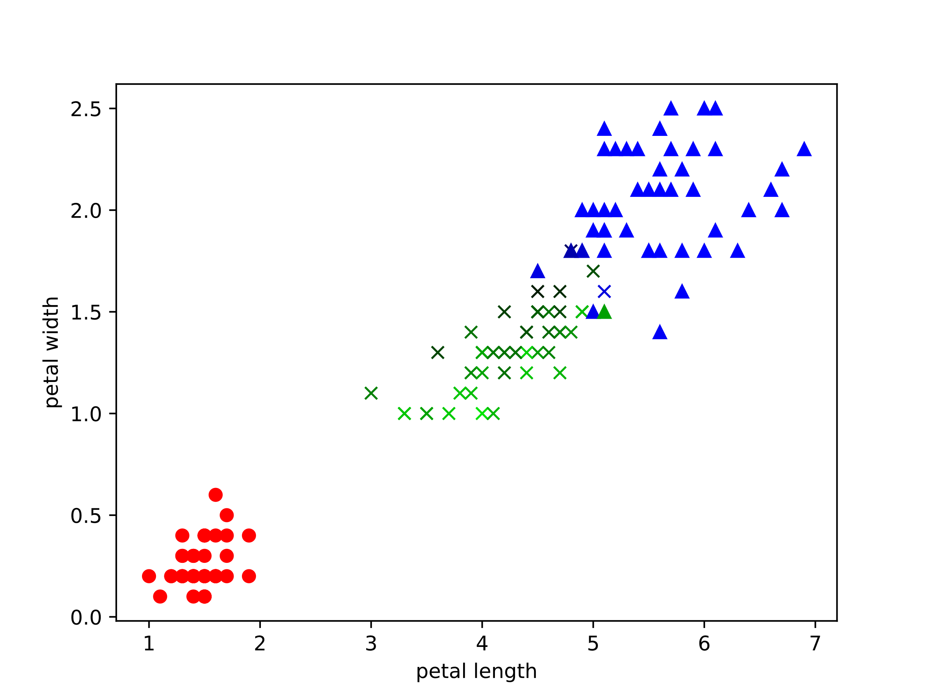
Figure 1 One vs many classification

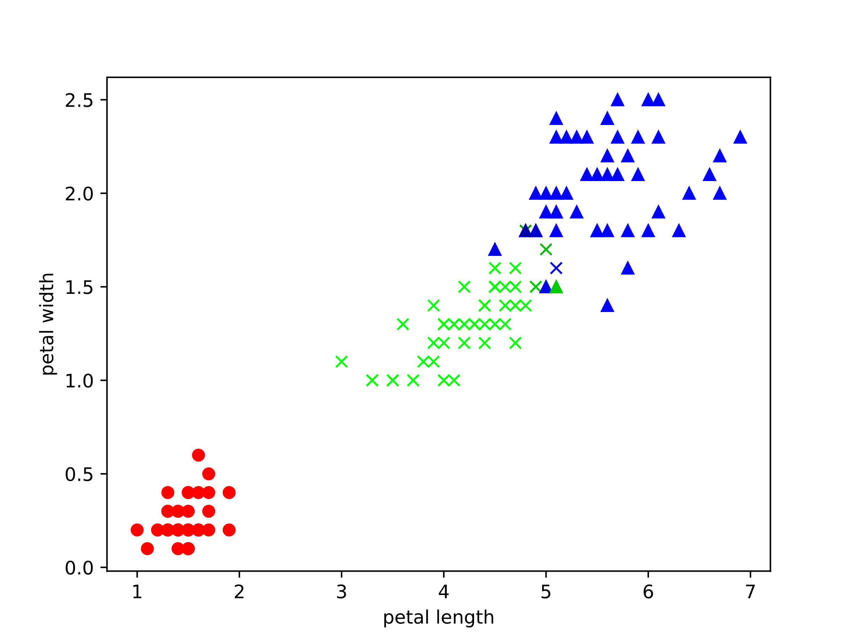
Figure 2 Classification through one single multinomial logistic regressor
In our example, the classifications are identical although the probabilities differ slightly. Concerning the underlying model assumptions, however, both approaches are not equal.
For a detailed analysis of the different assumptions, see here:
https://stats.stackexchange.com/questions/52104/multinomial-logistic-regression-vs-one-vs-rest-binary-logistic-regression

9A-3.

For the calculation, please consult the “LectureLogistic” slide and look at page 13.
$$Error rate=\frac{FP+FN}{TP+TN+FP+FN}=\frac{50+10}{90+10+50+150}=\frac{60}{300}=0.2$$
$$Precision=\frac{TP}{TP+FP}=\frac{90}{90+10}=0.9$$
$$Recall=TPR=\frac{TP}{TP+FN}=\frac{90}{90+50}=\frac{9}{14}$$
$$Specifity=\frac{TN}{TN+FP}=\frac{150}{150+10}=\frac{15}{16}$$

To makes an inference about the ROC curve, let us calculate $FPR:$
$$FPR=\frac{FP}{FP+TN}=\frac{10}{10+150}=\frac{1}{16}$$
This gives us the ROC coordinate $\left(FPR,TPR\right)=\left(1/16,9/14\right).$
Naturally, we also have the points $\left\{\left(0,0\right),\left(1,1\right)\right\}$. This is the case, because the class probability $P\left(C_{1}|x\right)$ can never reach exactly one (see previous exercise A.7-4 for that) if our boundary is $θ=1$.
A rough sketch is therefore:
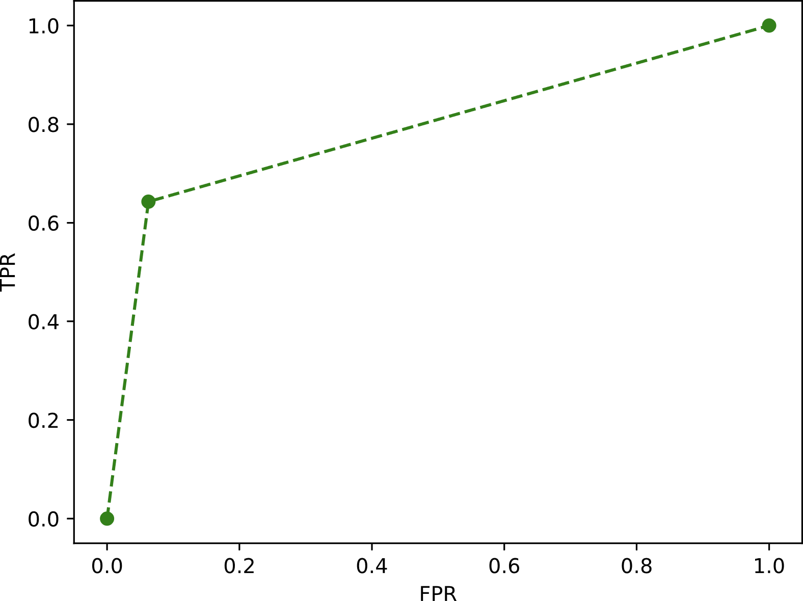
This classifier appears to be robust at separating the data, as $FPR≈0$ appears to be near the origin and
$TPR≈0.64$ .

